Study App User Guide

Prepared by Azaria Dunston

# INTRODUCTION

The Study App is an app designed to help students in high school and college with being more efficient with their studies. The app has a timer and a to-do list.

# DIRECTIONS

**When You Open the App**

1. When you open the app, you will be greeted with a welcoming message and some information about the app. Press ENTER to move on after reading.
2. 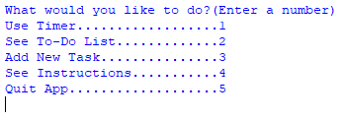You will then be shown the menu, which should look something like this:

**To Use The Timer**

1. At the menu, type the number 1 and press ENTER.
2. You will be asked a series of questions to set up the timer.
3. “Do you want a countdown timer?” This will determine if the timer will count down or up. If you want the timer to count down, type “yes” and press ENTER. If not, type “no” and press ENTER.
4. “How many minutes do you want to study?” Type the number of minutes you want to study and press ENTER. Please enter a *positive integer*.
5. “Start the timer?” When you are ready to start the timer, type “yes” and press ENTER. Once you do, the timer will start. At the moment there is no way of pausing the timer.  
   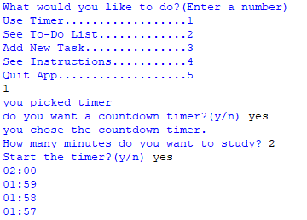
6. When the timer is finished, it will display a message saying so and take you back to the menu.

**To See Your To-Do List**

1. At the menu, type the number 2 and press ENTER. All the tasks currently in your to-do list will be displayed on screen sorted by their subject.

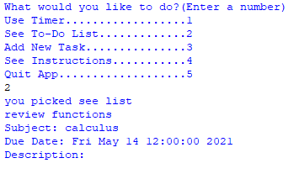

**To Add a Task to Your To-Do List**

1. At the menu, type the number 3 and press ENTER.
2. You will be asked a series of questions to create a new task
   1. “Enter the name of your task:” Enter a descriptive name of your task like “take math quiz” or “Chapter 4 homework.”
   2. “Enter the subject it belongs to:” Enter the name of the subject or class that your task is related to. This will help the app with sorting the to-do list. Please be consistent with the subjects you enter
   3. “When is it due?” Enter the due date of your task. You *must* enter the due date in the following format: MON DD HH:MM YYYY
   4. “Write a description of this task:” If there are any important details you would like to remember about this task, type them after this prompt. If not, press enter to skip this step.
3. After you have answered all the questions, it will display a message, confirming that your task has been added to your to-do list.

